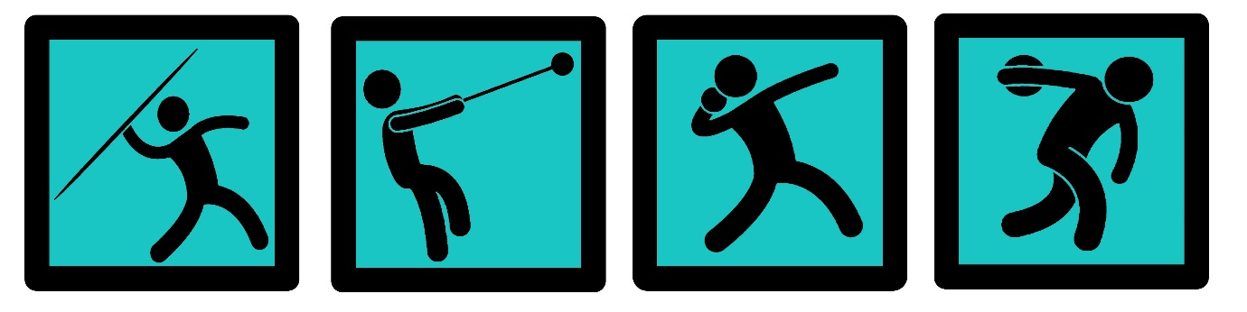

Burton Ac Winter Training 2019
- Training starts at 6pm ready for the warmup , simply no warm-up no training regardless of what you have been doing during the day…. Your body will have cooled down so you will need to get warmed up again to prevent injury.
- Training will finish around 7:45-8pm, so be prepared to finish at that time unless you really need to go or leave early.
- You will only get out of winter training what you put into it!!!! Don’t expect to see the results you simply didn’t work hard enough for next season.
- Follow the training plans and complete every part of them, especially the parts you do not like, whether that be lifting, Medball or sprints….
- The aim of winter training is to make you faster, Stronger and fitter and be all rounded athletes…. Always look to be an athlete first.
- The first three months of winter we won’t be doing a great deal of throwing, but we will be doing conditioning……and gearing our muscles and bodies up for throwing next year….
- U13/u15 athletes at county level need to be doing 2-3 sessions a week. U13/u15 athletes at national level need to be doing 3 sessions a week.
- U17/u20 and senior athletes at club and county level need to be doing 3-4 sessions a week to see improvements in strength and speed. County and national level need to be training 4-5 days a week. Anything less than this and you will only see marginal improvements.
- During training its important you keep Hydrated and keep warm, so please make sure you bring a drink and bring warm clothing to training and ideally waterproof.
- Lifting weights can also cause your hands to develop hard skin, so ideally wearing lifting gloves will prevent this.
- I don’t want any athlete using protein powders or drinks below u17. If you are using protein powders and drinks to aid recovery, please consult me. U13/u15 athletes can get plenty of protein in their diet purely with foods such as eggs, Fish, Chicken, etc… if you need Nutritional advice please come and talk to me and we can design you a plan.
- Lifting weights is paramount in building lean muscle and getting strong and don’t think by getting strong you have to get big or bulky, some of the strongest men and women in the world are not big or bulky.
- When lifting weights , Please warm up, Also have a spotter and use a belt and gloves.
- The programmes I have designed for you are built on trust and require you to be self sufficient , there is going to be times in training where you will have to follow the plans yourselves and also on non-training days, so don’t cheat yourself by skipping days or skipping parts of the plan.
- You will need to purchase , A resistance Band, Weight lifting gloves , A water bottle , a weight lifting belt…

So enjoy winter training guys, Lets get fit, lets get fast , lets get strong and lets get ready for next year……

